**Chapter 1**

**Introduction**

Runming Yao

School of Civil Engineering, Chongqing University, China

School of the Built Environment, University of Reading, UK

Emails: r.yao@cqu.edu.cn/r.yao@reading.ac.uk

**Abstract**

This introductory chapter sets the scene for the book, providing an overview of sustainability and resilience in the urban environment. It illustrates the impact of climate change on the living environment thus affecting people’s health and well-being. Interventions to mitigate the impact through instruments of policy and technical solutions are provided. Computer modelling and simulations provide tools for scenario analysis to assist risk forecasting and decision makings of mitigation strategies. Case studies provide examples of sustainable and resilient urban design and policy implementation which are hoped to be useful to the readers.

**Keywords:** Sustainability, Resilience, Health and well-being, Heat stress, Modelling, Air quality, Noise, Biodiversity, Green infrastructure, Flood, Water, Policy

* 1. **Background**

According to ‘the World Bank Overview (https://www.worldbank.org/en/topic/urbandevelopment/overview) today, some 56% of the world’s population – 4.4 billion inhabitants – live in cities. This trend is expected to continue, with the urban population more than doubling its current size by 2050, at which point nearly 7 of 10 people will live in cities.

Citizens’ daily activities in a city are relying on living environment conditions and resources like pleasant temperatures, clean air, clean water, flood resilience, acceptable acoustic environment, sufficient energy supplies, affordable living supplies and so on (IPCC, 2018). Those elements are fundamental for providing a healthy environment for people to live in and maintaining city sustainability and resilience.

**Temperature**

Climate change increases the likelihood of heatwave events, posing great threats to human health as well as resulting in increased mortality and human thermal discomfort. Extreme temperature events have been classified as one of the most dangerous global disasters (WMO 2021). Between 1998~2017 more than 166,000 people died due to extreme temperatures, and especially in 2003 over 70,000 people were killed in heatwaves in Europe (CRED and UNISDR 2018). In the UK, heatwaves, in June and August 2020, caused more than 2000 deaths (PHE 2020; Thompson et al. 2022). Heatwaves would make the Urban Heat Island (UHI) intensity substantial, bringing heat-related health issues for city dwellers worldwide (Macintyre et al. 2018; Iping et al. 2019; He et al. 2022).

Heat has direct and indirect impacts on health issues (Figure 1.1). Excessive heat can directly cause dehydration and even the development of emergency hospitalizations and require immediate management, such as heat stroke, heat exhaustion, and heat syncope (WMO and WHO 2015). Indirectly, it can alter human behaviours, increase the transmission of diseases, disrupt critical infrastructure and so on. Thus establishment of the protection in addressing the above issues is very necessary, as does increasing the resilience of the city as well as protecting citizen health.

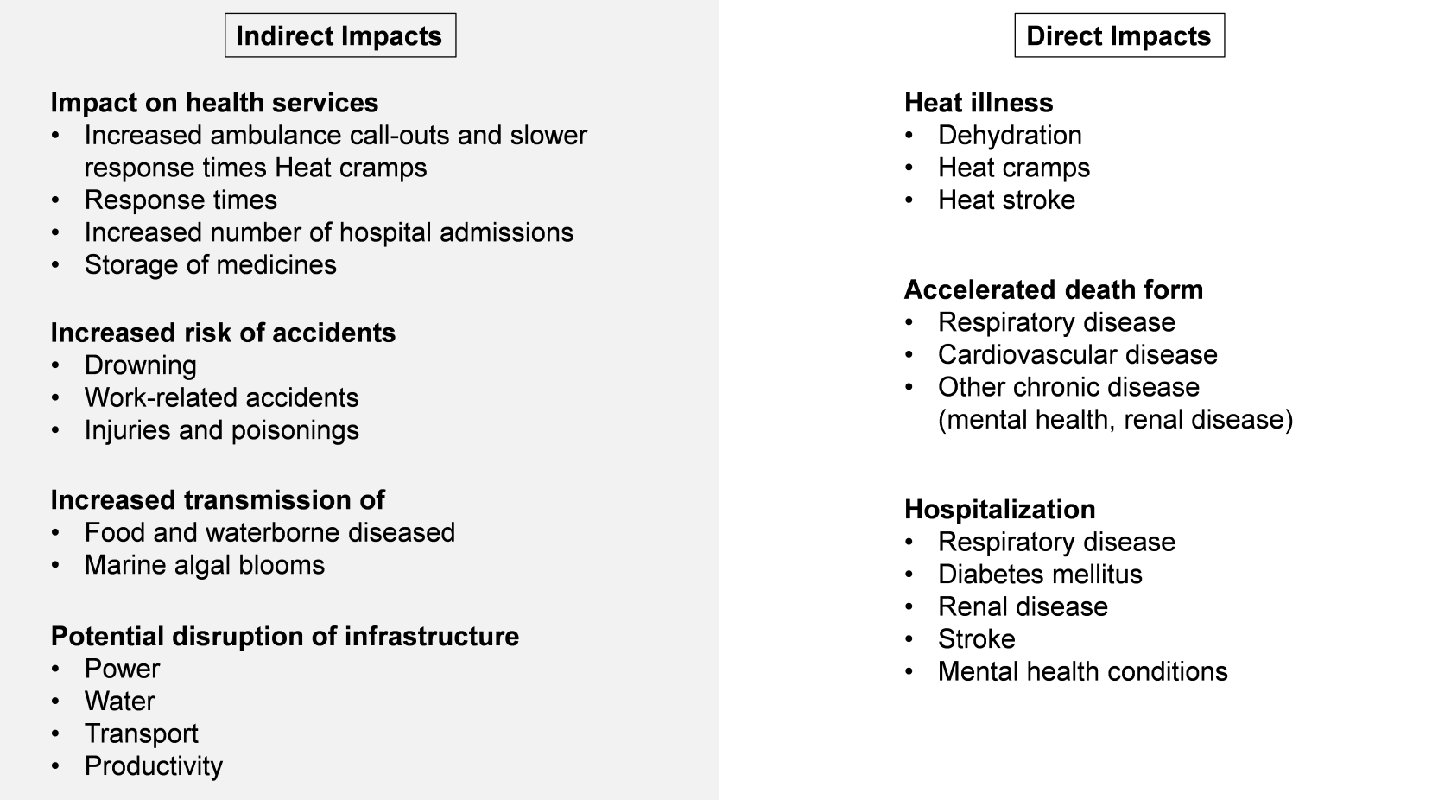**Figure 1.1** The impacts of extreme heat on health (WHO Heat and Health, 2023)

**Air**

Air pollution is the presence of toxic chemicals or compounds (including those of biological origin) in the air, at levels that are one of the greatest environmental risks to health ([Seinfeld](https://xueshu.baidu.com/s?wd=author:(JH%20Seinfeld)%20&tn=SE_baiduxueshu_c1gjeupa&ie=utf-8&sc_f_para=sc_hilight=person) and Pandis, 1998). Epidemiological studies revealed that air pollution is a risk factor for diseases of public health importance such as cardiovascular diseases for instance stroke and ischemic heart disease, cancers, and respiratory diseases (Cohen et al., 2015). Ambient (outdoor) air pollution is estimated to have caused 4.2 million premature deaths worldwide in 2019 (WHO, 2023).

World Health Organization (WHO) data show that almost all of the global population (99%) breathes highly polluted air that exceeds WHO limits (WHO, 2023). WHO aggregates global particulate matter data and collates them into reports. Figure 1 shows the annual mean concentration and the coverage of the ground measurements of PM2.5 for countries around the world from 2010-2016. It shows that countries with low- and middle-income suffer from the highest exposures.

Referring to sources of air pollutants, the burning of fossil fuels motor vehicles and power stations are the major source, which is one of the biggest causes of air pollution in developing countries. As a typical large developing country, China's growing energy consumption, reliance on coal, and rapidly increasing vehicle population cause severe air pollution. Air pollution concentration levels tend to increase appreciably or even rise sharply if no effective measures are taken when economic development reaches an intermediate stage (WHO, 2013). Hence, there is a growing need to create better living spaces and ensure human well-being. Sustainable urban planning and climate control measures are required to maintain and improve public health.

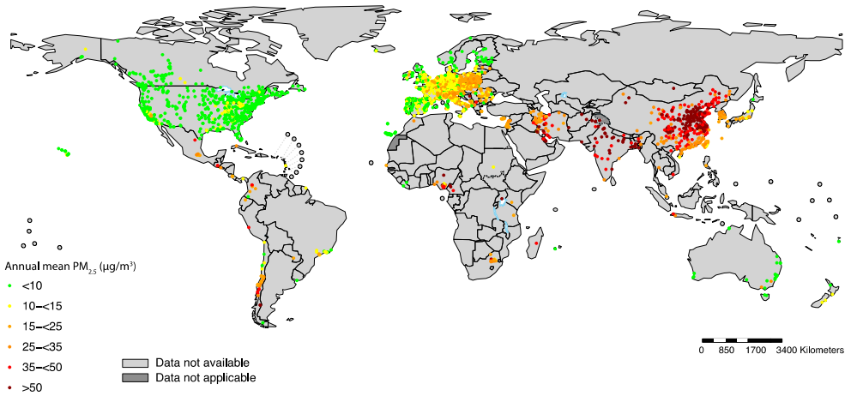

**Figure 1.2** Location of the monitoring stations and PM2.5 concentration in more than 4000 human settlements, 2010‐2016 (WHO, 2018)

As shown in Figure 1.2, the location of the PM2.5 concentration in more than 4000 monitoring stations was listed on the map. Particulate matter (PM), carbon monoxide (CO), ozone (O3), nitrogen dioxide (NO2) and sulfur dioxide (SO2) are the main pollutants of major public health concern (WHO, 2023). Harmful pollutants exposure is proven to be associated with respiratory illness, hospital admission and premature death (Huangfu and Atkinson, 2020). The health impacts of ambient PM2.5 have become a great concern worldwide. Epidemiological investigations have shown that PM2.5 exposure contributes to cardiopulmonary morbidity and mortality, the incidence and development of diabetes mellitus

and adverse birth outcomes (Feng et al., 2016). Considering the significant health risks posed by pollutants, interventions at regional, national and international levels are needed to reduce levels of air pollution.

**Water**

Water in urban is necessary in terms of human daily activities needs and sanitation needs. The water quality and quantity played a vital role in city resilience. Hygiene behavior by using clean water can significantly reduce respiratory infections (Howard et al., 2020). Water quantity is limited, fresh water accounts for only 2.5% of the global water ([Tang et al., 2022](https://www.sciencedirect.com/science/article/pii/S0195925523000562" \l "bb0110)), and the reliability of the water is heavily connected with human well-being. United Nations Sustainable Development goals emphasise the sanitation and quantity needs for water in the city, to satisfy SDG 6, the Guidelines for Drinking-water Quality (GDWQ) provide the recommendations of the World Health Organization for managing the risk from hazards that may compromise the safety of drinking water, and assist water and health regulators and policymakers to maintain public health by supporting the development of national regulations and standards.

**Flood**

Over the last 20 years, flood events have occurred in 49 countries in the WHO European Region. These have caused more than 2000 deaths, other health effects, property losses, damage to health facilities, displacement and enormous economic costs ‎estimated at €70 billion (WHO Flooding, 2017). Flooding is widely regarded as extreme water stress or land loss disaster in urban or rural areas on the mainland. Understanding flooding and increasing the robustness capacity against flood risk are important for human well-being. Flooding effects included accident and injury risk; diarrhoeal/respiratory diseases and skin/eye infections; chemical poisoning; stress; and negative health effect linked to overcrowding (WHO Flooding, 2017). The second effect can occur after floods, for example, damage to health care infrastructures, living supplies, water shortage, communication crash, destruction of property and vital community facilities, damage to crops, disruption of food supplies, and disruption of livelihoods and income. A flood warning measures system is, therefore, very necessary for city resilience, strengthening the monitoring of flood hazard points, establishing and improving monitoring systems, observing models, forecasting models, and early warning systems, group measurement and prevention work are now considered as potential solutions.

**Acoustic**

Noise pollution in urban environments caused by traffic is nowadays recognized as one of the top public health threats across all ages (UNEP, 2022). Prolonged exposure to high levels of noise impairs human health and well-being. Traffic and other urban noises affect not only human well-being but also disturb and endanger the survival of species crucial to the urban environment (Francis and Barber, 2013).

Estimates suggest that in Europe 22 million and 6.5 million people suffer from chronic noise annoyance and sleep disturbance, respectively (EEA, 2020). The elderly, pregnant woman and shift workers are among those at risk of noise-induced sleep disturbance (Halperin, 2014). Noise-induced awakenings can trigger a range of physiological and psychological stress responses because sleep is necessary for hormonal regulation and cardiovascular functioning (Münzel et al., 2014). There is increasing evidence that traffic noise exposure is a risk factor for the development of cardiovascular and metabolic disorders such as elevated blood pressure, arterial hypertension, coronary heart disease and diabetes (Münzel et al., 2018).

**Table 1.1** Prevalence of hearing loss (of moderate or higher grade) across WHO regions (WHO, 2021)

|  |  |  |
| --- | --- | --- |
| Area | Quantity / million | Proportion |
| Americas | 62.7 | 6.2% |
| African | 39.9 | 3.6% |
| European | 57.3 | 6.2% |
| Eastern Mediterranean | 22.1 | 3.1% |
| South-East Asia | 109.4 | 5.5% |
| Western Pacific | 136.5 | 7.1% |

Table 1.1 shows the prevalence of hearing loss across WHO regions, the highest proportion is Western Pacific (accounting for 7.1%, 136.5 million), and the lowest is in Southeast Asia (3.1%). Also, European and the Americas should concern due to the relatively high index.

**Table 1.2** Illustrative combined direct, indirect and intangible costs of hearing loss (in billion dollars) (David et al., 2021)

|  |  |  |  |  |  |
| --- | --- | --- | --- | --- | --- |
| Area | Health | Education | Productivity | Intangible | All costs |
| Americas | 88.6 | 3.8 | 44.1 | 125.3 | 262 |
| African | 7.3 | 3.6 | 3.5 | 12.4 | 27.1 |
| European | 74.5 | 3.2 | 21.1 | 125.6 | 224.5 |
| Eastern Mediterranean | 9.0 | 1.6 | 5.2 | 13.9 | 29.8 |
| South-East Asia | 32.2 | 7.0 | 29.7 | 38.7 | 107.7 |
| Western Pacific | 101.8 | 7.4 | 78.5 | 140.5 | 328.3 |
| World | 313.6 | 26.8 | 182.4 | 456.5 | 979.6 |

Table 1.2 above indicated hearing loss has a considerable economic impact on society as a whole. WHO data reveal that the overall global cost of unaddressed hearing loss is greater than $ 980 billion annually.

* 1. **Energy and Environment**

With the rapid urbanisation and urban sprawl, global demand and consumption of energy by cities are constantly increasing. Cities consume approximately 67% of the world’s energy, and their carbon emissions have surpassed 70% of the global total (IEA, 2021). It is estimated that by 2040, the building sector will account for 35% of the global electricity demand growth. The rapid increase in urban energy consumption and carbon emissions is of concern and there is an urgent need to take measures to promote energy conservation and emission reduction in cities.

Fossil fuel combustion is the main contributor to carbon emissions to meet urban energy demand. The combustion of carbon-based substances causes a large amount of carbon dioxide emissions into the air and bring potential negative health effect on the human. Mitigation of carbon emissions needs to implement a zero energy building policy. Clean and renewable energy is the most important issue for a city’s sustainability and resilience.

Human activities and urbanization have a negative impact on biodiversity comparing its original nature elements. Landscape plant species with their notable influence on human well-being, are important components of the urban ecosystem. Urban greening is expected to avoid biotic homogenization. This will help the urban designer thinking as well as the decision-making on protecting human well-being and environmental biodiversity. Urban biodiversity study can determine the practical relevance of tools for different types of audiences, including designers, planners, and ecology working in different stages of urban development and design processes.

* 1. **Sustainability and resilience**

Urban Sustainability consists of appreciating and balancing the three pillars of sustainable development (economic, social and environmental), whilst also being inclusive and equitable. While City Resilience indicates the city's capacity to adapt to changing conditions and withstand and rapidly recover from disruption due to emergencies. A sustainable and resilient city is the development path for future cities facing increasingly unknown urbanization challenges. Responding to climate change, policies are recognized as mandatory guiding decisions that can safeguard the fair interests of the majority of people and thus plays a vital role in society. United Nations Sustainable Development Goal (UN SDG) is promoted for providing a sustainable index and goals for humans, requiring people in all stages together to build a sustainable world for humans and the next generation. The target of ‘Good health and well-being’ is one of the United Nations' 17 Sustainable Development Goals.

The holistic system thinking approach is considered in the improvement of urban living environments. Cities require a systems approach for planning, design and management. The living environment as a whole in a city covers all aspects like a community unit together as a pyramid, it needs intelligent structures and infrastructures, social provision, amenities and basic property rights for its citizens. It is essential to set a vision for all the stakeholders so they feel comfortable and have easy access to clean, sufficient and daily needs. The sustainable and resilient city should have functions of providing sufficient energy, clean air and water, flood resilience, and be accessible to everyone. System thinking is a key improvement in an urban living environment.

* 1. **Summary**

The liveable cities include factors affecting liveability; ecological and biophilic cities; economic values; health and well-being and opportunities for people. There is a basic human need for a social dynamic and cities provide this for people. Cities are like organisms pulsing with life bounded by economic, ecological, health, and well-being requirements. Physical and social health is addressed in the context of resilient cities in Chapter 2. This Chapter defines the features of sustainable liveable cities and reviews how cities can function in a climate change-respectful way but also be joyful places for people to be.

People in cities use outdoor space for a wide range of activities such as exercise, rest, and socialising. Climate change, Urban Heat Islands, and extreme heatwave events are threats to pedestrians’ health and well-being. Good urban planning and design can provide a high-quality urban living environment by meeting the need for outdoor thermal comfort and thermal resilience. Chapter 3 presents the human adaptation mechanism for achieving outdoor thermal comfort, the factors that influence it, strategies for thermal resilience, the management of heat risk, and thermal comfort assessment methods to use.

Heatwaves and high temperatures are associated with increased mortality risks and the burden may keep rising in the future. Chapter 4 provides evidence of climate change and the mortality risks of heat waves and high temperatures. This study examined the population's vulnerability to heatwaves and high temperatures, including demographic and climatic modifications, highlighting the necessity for adaptation measures against heat stress to contribute to the reduction of the heat-related mortality burden. The method of estimating the city-specific risks has been presented.

The computer modelling method is one of the effective measures that can help assess urban environments and decision makings of urban intervention strategies for the improvement of people’s health and well-being. It plays an important role in the resilience of cities. It has been widely conducted in many aspects including assessment of outdoor thermal comfort, urban heat islands, urban air quality, urban flooding, urban ventilation design, urban acoustic and flooding. It can assist policy-makers, urban designers, and city managers to work collaboratively to deliver sustainable urban planning and regeneration from the earliest stage. Chapter 5 introduces a robust and fast-running tool that can be used to simulate urban solar radiation, surface temperatures, and air temperature. It can be used in a variety of scenarios to assist in the assessment of urban planning/building design projects related to the outdoor thermal environment. The case study presented briefly demonstrates some of the functions that can be used in the planning and design phase. Chapter 6 presents the challenges of modelling complex physical phenomena in terms of the prediction of characteristics and evolution with adequate accuracy and reliability. Data assimilation techniques incorporate information from experiments and observations to reduce uncertainties in numerical prediction has been presented. The resolutions of modelling techniques on an urban scale have been demonstrated with case studies of simulations of urban air pollution, urban green-blue infrastructure and land surface thermal dynamics, and urban flooding forecasting.

Inhabitants of high-rise and high-density cities are at greater risk of severe environmental hazards, such as air pollution. Typically, high-density cities have high pollutant emission rates, attributable to high traffic volume per unit area. Urban ventilation is one of the practical measures through proper urban and building design that can mitigate urban heat and air pollution. Chapter 7 presents six design principles that can improve urban ventilation in high-density cities and therefore reduce air pollution exposure. By incorporating climate-sensitive design strategies, high-density cities can potentially reduce both indoor and outdoor exposure to air pollution, leading to improved sustainability and resilience. Chapter 8 presents the impact of the urban context in terms of air and thermal pollution on ventilation strategies. Three case studies of the performance evaluation of buildings in urban areas are presented.

The acoustic quality of living and working environments can affect the health, well-being and quality of life of building occupants. Chapter 9 introduces the soundscape methodologies that provide a comprehensive characteristic of acoustic perception by people in a specific context, thus guiding the design of built environments to shape resilient cities, able to address the main global challenges posed by global warming. The consideration of soundscape aspects from the earliest stages of urban planning and building design would favour conditions that allow for the adoption of passive ventilation (and cooling) strategies for occupants’ health and well-being.

Rapid urbanization has greatly affected global biodiversity. Human preferences for the plant species of urban greening have greatly facilitated the spread of non-native species, resulting in the homogenization of landscape plant communities across spatial scales. Chapter 10 explores the climatic suitability and sustainability of landscape plants for urban biodiversity. The application of biodiversity-friendliness spontaneous urban plants (SUPs) has been proven an effective way to urban diversity in 59 major cities in China.

Nature-based measures like green infrastructures have been regarded as a multifunctional approach to urban resilience and sustainability for capturing particulate matters and mitigating the impact of urban heat islands at the city scale, acting as nature-based solutions to abate the impact of natural hydro-meteorological hazards such as flooding and heatwaves, to indirectly foster biodiversity. Chapter 11 summarises the design principles and the role of green infrastructure (GI) in the abatement of air pollution, urban heat, and natural hazards. The GI method has been proven to contribute to improved health and well-being in terms of sustainable and resilient cities.

Floods threaten cities in various forms whose magnitude and frequency are likely exacerbated by climate change and increasing urbanisation. Chapter 12 explains their causes, consequences, observation methods, hazard modelling techniques, and mitigation infrastructures relevant to urban flood resilience. It introduces hybrid infrastructure (grey, green and blue) systems for urban resilience to flooding. It is addressed that flooding risk has to be managed through resilient and sustainable planning, especially in fast-developing areas.

The global success of mitigating climate change is dependent on transitions to net zero carbon energy systems. The increasing urbanization of global populations inevitably increases the energy demand for working, living and improving living environments, transportation, entertainment, and so on. Chapter 13 presents the relationship of different causal pathways (top-down and bottom-up) to demand reduction in cities. It presents a matrix of the five demand reduction sectors and seven demand reduction trends as of the Low Energy Demand Scenarios (CREDS) for the potentials of energy demand reduction in the context of urban sustainability.

Mitigation of carbon emissions needs to implement a zero energy building policy. Clean and renewable energy is the most important issue for a city’s sustainability and resilience. Chapter 14 introduces the applications of renewable energy including solar water heating, space heating and cooling systems, photovoltaics, and hybrid photovoltaic and solar thermal (PV/T) systems which provide both thermal and electrical energy; and the geothermal energy systems which employ ground heat exchangers in combination with heat pumps. Renewable energy systems are used not only in buildings directly but nowadays are also used in district heating and cooling networks in the urban/community context for a sustainable future.

The evolution of policies by setting frameworks plays a pivotal role in the delivery of sustainable and resilient cities. Chapter 15 presents examples of implementations of policies and sustainable development guides as well as tools in cities toward a more resilient, sustainable, and liveable future. It includes exemplary cases from London, Shanghai, Accra, Singapore, Amsterdam and Melbourne. These include urban forests, urban agriculture, water storage and reuse, flood management using nature-based solutions, walking, cycling, and electric public transport for mobility, and using waste as a resource.

The case study of the implementation of energy policy for zero-carbon cities (communities) in Japan has been introduced in Chapter 16. The proposals made by the Architectural Institute of Japan and the Science Council of Japan regarding zero-carbon cities and communities are explained and discussed. An overview of the decarbonization efforts in 26 regions selected as decarbonization leading areas and specific examples of four regions is provided. It further demonstrates the policy's role in delivering sustainable cities.

The scarcity of freshwater across the world has become one of the major crises exacerbated by a growing population, changing consumption patterns, and the rise in irrigated agriculture. Chapter 17 presents the developing country, Indian case studies of household end-use water demand, and the innovative decentralized water system, which combined rainwater harvesting (RWH) with wastewater. Guidance of five points for urban water resilience has been proposed to increase city resilience in the context of end-user and management through scenario analysis.

A long-term integrated approach is crucial in planning and implementing green and liveable cities. On the one hand, this requires cross-departmental and multidisciplinary collaboration, as well as wider citizen engagement, on the other hand, it requires a long-term strategy that considers the whole lifecycle of creating sustainable and resilient places starting from visioning, planning, implementation, enforcement, management, and maintenance, as well as monitoring and feedback. Chapter 18 introduces two UK case studies to discuss how the long-term integrated approach can be utilised: the first case study of Cornwall Council is focused on its inclusive and integrated policymaking process; the second case study of Milton Keynes is focused on the long-term strategy of planning and implementing its city-wide green infrastructure.

Chapter 19 looks beyond well-recognised factors like thermal quality, addressing lifestyle and balance, and social influences on ‘well-being in use’, including location, spatial scale, biophilia, ‘active by design’, community, and social memory. This has been demonstrated by drawing on the author’s rich repertoire of research and practical experience in people’s use of buildings and urban spaces. It implicitly proposes a breadth of professional expertise to shape healthy environments.

Chapter 20 addresses the importance of city governance in shaping the future of a city. It introduces the overall concept of urban future thinking. The Reading case study in the UK demonstrates that the cities with the most robust and effective ‘hard’ and ‘soft’ climate change, governance structures will be the cities that continue to attract investment. The key points are addressed that can be learned by other cities and towns in achieving sustainable and resilient cities, towns, and communities. They include Integrated approach, Role of stakeholders, Power relations, R & D opportunities, COVID and resilience, and net Zero. Ultimately people, businesses, local government, academia, and other key city stakeholders must all be part of helping shape that future.

**References**

CRED, UNISDR (2018) Economic losses, poverty & disasters: 1998-2017. Centre for Research on the Epidemiology of Disasters (CRED). United Nations Office for Disaster Risk Reduction (UNISDR). <https://www.undrr.org/publication/economic-losses-poverty-disasters-1998-2017>.

Cohen J (2015) Estimates and 25-year trends of the global burden of disease attributable to ambient air pollution: an analysis of data from the Global Burden of Diseases Study 2015. Lancet, 389(10082), 1907–1918. https://doi.org/10.1016/S0140-6736(17)30505-6.

David M and Shelly C (2021) Estimating the global costs of hearing loss. International Journal of Audiology, 60(3), 162-170. https://doi.org/10.1080/14992027.2021.1883197.

EEA (European Environment Agency) (2020) Environmental noise in Europe — 2020. Luxembourg: Publications Office of the European Union. <https://doi.org/10.2800/686249>.

Francis C, Barber J (2013) A framework for understanding noise impacts on wildlife: an urgent conservation priority. Frontiers in Ecology and the Environment 11(6), 305-313. <https://doi.org/10.1890/120183>.

Feng S, Gao D, Liao F, Zhou F, Wang X (2016) The health effects of ambient PM2.5 and potential mechanisms. Ecotoxicology and environmental safety, 128, 67–74, https://doi.org/10.1016/j.ecoenv.2016.01.030.

Halperin D (2014) Environmental noise and sleep disturbances: A threat to health? Sleep Science, 7(4), 209-212. <http://doi.org/10.1016/j.slsci.2014.11.003>.

He B, Wang J, Zhu J, Qi J (2022) Beating the urban heat: Situation, background, impacts and the way forward in China. Renewable and Sustainable Energy Reviews, 161, 112350. <https://doi.org/10.1016/j.rser.2022.112350>.

Howard G, Bartram J, Williams A, Overbo A, Fuente D, Geere J (2020) Domestic water quantity, service level and health, Second Edition. World Health Organization, Copenhagen, ISBN 978-92-4-001524-1.

Huangfu P, Atkinson R (2020) Long-term exposure to NO2 and O3 and all-cause and respiratory mortality: A systematic review and meta-analysis, Environment international, 144, 105998. https://doi.org/10.1016/j.envint.2020.105998.

IEA (International Energy Agency) (2021). Empowering Cities for a Net Zero Future: Unlocking Resilient, Smart, Sustainable Urban Energy Systems. OECD Publishing. https://iea.blob.core.windows.net/assets/4d5c939d-9c37-490b-bb53-2c0d23f2cf3d/G20EmpoweringCitiesforaNetZeroFuture.pdf. Accessed 18 May 2023.

Iping A, Kidston-Lattari J, Simpson-Young A, Duncan E, McManus P (2019) (Re)presenting urban heat islands in Australian cities: A study of media reporting and implications for urban heat and climate change debates. Urban Climate, 27, 420-429. <https://doi.org/10.1016/j.uclim.2018.12.014>.

IPCC (Intergovernmental Panel on Climate Change) (2018) Special Report on Global Warming of 1.5℃. <https://www.ipcc.ch/sr15/>. Accessed 3 May 2023.

Münzel T, Gori T, Babisch W, Basner M (2014) Cardiovascular effects of environmental noise exposure. European Heart Journal 35(13), 829–836. <https://doi.org/10.1093/eurheartj/ehu030>.

Münzel R, Schmidt F, Steven S, Herzog J, Daiber A, Sørensen M (2018) Environmental Noise and the Cardiovascular System. Journal of the American College of Cardiology, 71(6), 688-697. <https://doi.org/10.1016/j.jacc.2017.12.015>.

Macintyre HL, Heaviside C, Taylor J, Picetti R, Symonds P, Cai XM, Vardoulakis S (2018) Assessing urban population vulnerability and environmental risks across an urban area during heatwaves – Implications for health protection. Science of The Total Environment 610, 678-690. <https://doi.org/10.1016/j.scitotenv.2017.08.062>.

PHE (2020) Heatwave mortality monitoring report: 2020. Public Health England (PHE). <https://www.gov.uk/government/publications/phe-heatwave-mortality-monitoring/heatwave-mortality-monitoring-report-2020>. Accessed 22 Nov 2022.

Seinfeld J, Pandis S (1998) “Atmospheric chemistry and physics: from air pollution to climate change,” John Wiley Sons.

Tang W, Pei Y, Zheng H, Zhao Y, Shu L, Zhang H (2022) Twenty years of China's water pollution control: Experiences and challenges. Chemosphere, 295, 133875. https://doi.org/10.1016/j.chemosphere.2022.133875.

The World Bank , https://www.worldbank.org/en/topic/urbandevelopment/overviewAssessed 21 December 2023.

UNEP (United Nations Environment Programme) (2022) Frontiers 2022: Noise, Blazes and Mismatches – Emerging Issues of Environmental Concern. Nairobi.

WHO (2018) Heat and Health. <https://www.who.int/news-room/fact-sheets/detail/climate-change-heat-and-health>. Accessed 4 May 2023.

WHO (2017) Flooding: Managing health risks in the WHO European region, World Health Organization, Copenhagen. ISSN 978289052795.

WHO (2021) World report on hearing, World Health Organization, Geneva, ISBN 978-92-4-002048-1.

WHO (2023) Ambient (outdoor) air pollution, World Health Organization. https://www.who.int/news-room/fact-sheets/detail/ambient-(outdoor)-air-quality-and-health. Accessed 9 May 2023.

WHO (2023) Air pollution. World Health Organization. https://www.who.int/health-topics/air-pollution#tab=tab_1. Accessed 9 May 2023.

WHO (2013) Health effects of particulate matter: policy implications for countries in eastern Europe, Caucasus and central Asia. World Health Organization, Copenhagen: WHO Regional Office for Europe, 2013.

WHO (2023) Heat and Health. World Health Organization. https://www.who.int/news-room/fact-sheets/detail/climate-change-heat-and-health, Accessed 15 May, 2023.

WMO (2021) WMO Atlas of Mortality and Economic Losses from Weather, Climate and Water Extremes (1970–2019). World Meteorological Organization (WMO). <https://library.wmo.int/index.php?lvl=notice_display&id=21930#.ZFPHTnbMJPa>.

WMO, WHO (2015) Heatwaves and Health: Guidance on Warning-System Development. World Meteorological Organization (WMO), World Health Organization (WHO). <https://www.who.int/publications/m/item/heatwaves-and-health--guidance-on-warning-system-development>.

WHO (2018) WHO ambient (outdoor) air quality database Summary results, update 2018. https://cdn.who.int/media/docs/default-source/air-quality-database/aqd-2018/aap_database_summary_results_2018_final2.pdf?sfvrsn=7b92eafc_3. Accessed 15 May 2023.